AP Statistics - Chapter 1A Extra Practice

1. | As part of survey of college students a researcher is interested in the variable class standing. She records a 1 if the student is a freshman, a 2 if the student is a sophomore, a 3 if the student is a junior, and a 4 if the student is a senior. The variable class standing is
A) | Categorical B) Numerical C) Quantitatively categorical D) all of the above

3. | A particularly common question in the study of wildlife behavior involves observing contests between “residents” of a particular area and “intruders.” In each contest, the “residents” either win or lose the encounter (assuming there are no ties). Observers might record several variables. Which of the following variables is categorical?
A) | the duration of the contest (in seconds) B) the number of animals involved in the contest
C) | whether the “residents” win or lose D) the total number of contests won by the “residents”

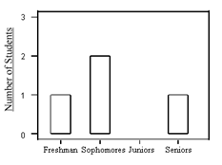
22. | At the right is a bar graph of class standing for a seminar containing seven students who are either freshman, sophomores, juniors, or seniors. (The bar for the juniors has been omitted.)  The number of students in the seminar who are juniors is
A) | 1 B) 2 C) 3 D) not able to be determined from the given info

7. | In drawing a histogram, which of the following suggestions should be followed?
A) | Leave large gaps between bars. This allows room for comments
B) | The heights of bars should equal the class frequency
C) | Generally, bars should be square so that both the height and width equal the class count
D) | The scale of the vertical axis should be that of the variable whose distribution you are displaying

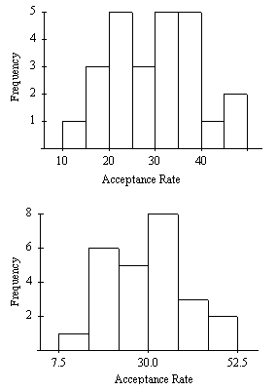
Each of the following two histograms represents the distribution of acceptance rates (percent accepted) among 25 business schools in 1995. The histograms use different class intervals but are based on the same data. In each class interval, the left endpoint is included but not the right.

8. | What percent of the schools have an acceptance rate of less than 20%?
A) | 3% B) 4% C) 12%  D) 16%

9. | Which interval contains fewer than half of all the observations?
A) | 20% ₌ acceptance rate < 35%
B) | 22.5% ₌ acceptance rate < 37.5%
C) | 25% ₌ acceptance rate < 40%
D) | 30% ₌ acceptance rate < 45%
In a statistics class with 136 students, the professor records how much money each student has in his or her possession during the first class of the semester. The histogram below is of the data collected.
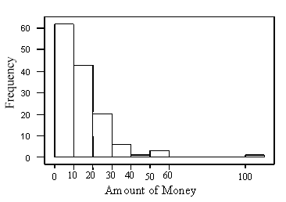
11. | The histogram
A) | is skewed right B) has an outlier C) is asymmetric D) all of the above

12. | The number of students with over $30 in their possession is
A) | less than 5 B) about 10 C) about 30 D) more than 100

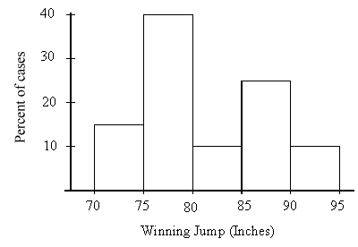
At the right is a histogram of the gold medal winning high jumps for the
Olympic Games.

13. | The mean of this histogram is approximately
A) | 75 inches B) 77.5 inches C) 82 inches D) 90 inches

14. | The percentage of these winning jumps that were at least  7 feet (84 inches) is about
A) | 9% B) 14% C) 23% D) 37%

29. | A researcher reports that, on average, the participants in his study lost 10.4 pounds after two months on his new diet. A friend of yours comments that she tried the diet for two months and lost no weight, so clearly the report must be a fraud. Which of the following statements is correct?
A) | Your friend must not have followed the diet correctly, since she did not lose weight
B) | Since your friend did not lose weight, the report must not be correct
C) | The report only gives the average. This does not imply that all participants in the study lost 10.4 pounds or even that all lost weight. Your friend's experience does not necessarily contradict the study results
D) | In order for the study to be correct, we must now add your friend's results to those of the study and recompute the new average

30. | The ages of people in a class (to the nearest year) are as follows:  Number of  What is true about the median age?
  Age | 18 | 19 | 20 | 21 | 22 | 23 | 24 | 25 | 32
  Students | 14 | 120 | 200 | 200 | 90 | 30 | 10 | 2 | 1
A) | It must be 20 B) It could be any number between 19 and 21 C) it must be 21 D) it must be over 21

35. | Suppose each employee in the company receives a $3000 raise for next year (each employee's salary is increased by $3000). The median salary for the employees working for the company will
 | A) be unchanged B) increase by $3000 C) be multiplied by $3000 D) increase by $\sqrt{\$\text{3000}}$

39. | A set of data has a median that is much larger than the mean. Which of the following statements is most consistent with this information?
A) | A stemplot of the data is symmetric  B) A stemplot of the data is skewed left
C) | A stemplot of the data is skewed right
D) | The data set must be so large that it would be better to draw a histogram than a stemplot

40. | In a class of 100 students, the grades on a statistics test are summarized in the following frequency table.  The median grade is in which of the following intervals?
  Grade | Frequency
  91–100 | 11
  81–90 | 31
  71–80 | 42
  61–70 | 16
A) | 61–70 B) 71-80 C) 81-90 D) 91-100

42. | Which of the following is likely to have a mean that is smaller than the median?
A) | the salaries of all National Football League players
B) | the scores of students (out of 100 points) on a very easy exam in which most score perfectly, but a few do very poorly
C) | the prices of homes in a large city
D) | the scores of students (out of 100 points) on a very difficult exam on which most score poorly, but a few do very well

A sample was taken of the salaries of 20 employees of a large company. The following are the salaries (in thousands of dollars) for this year. For convenience, the data are ordered.
28 | 31 | 34 | 35 | 37 | 41 | 42 | 42 | 42 | 47
49 | 51 | 52 | 52 | 60 | 61 | 67 | 72 | 75 | 77

44. | The first quartile of the 20 salaries is
A) | $35,000 B) $36,000 C) $37,000 D) $39,000

45. | The interquartile range of the 20 salaries is
A) | $19,000 B) $19,500 C) $21,500 D) $49,000

A sample was taken of the salaries of 20 employees of a large company. The following is a boxplot of the salaries (in thousands of dollars) for this year.
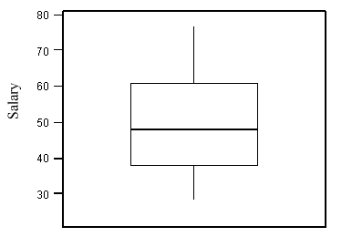

52. | Based on this boxplot, the five-number summary is
A) | 28, 39, 48, 60.5, 77 B) 28, 41, 48, 58, 77 C) 28, 39, 51, 58, 77 D) 28, 41, 51, 60.5, 77

The boxplot below is of the birthweights (in ounces) of a sample of 160 infants born in a local hospital.
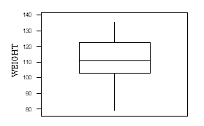
53. | The median birthweight is approximately
A) | 90 ounces B) 100 ounces C) 110 ounces D) 120 ounces

54. | About 40 of the birthweights were less than
A) | 92 ounces B) 102 ounces C) 112 ounces D) 122 ounces

55. | The number of children with birthweights between 100 and 120 ounces is approximately
A) | 40 B) 50 C) 80 D) 100

57. | A sample was taken of the salaries of 20 employees of a large company. The following are the salaries (in thousands of dollars) for this year. For convenience, the data are ordered.  Suppose each employee in the company receives a $3000 raise for next year (each employee's salary is increased by $3000). The standard deviation of the salaries for the employees will
  28 | 31 | 34 | 35 | 37 | 41 | 42 | 42 | 42 | 47
  49 | 51 | 52 | 52 | 60 | 61 | 67 | 72 | 75 | 77
 | A) be unchanged B) increase by $3000 C) be multiplied by $3000 D) increase by $\sqrt{\$\text{3000}}$

58. | The standard deviation of 16 measurements of people's weights (in pounds) is computed to be 5.4. The variance of these measurements is
A) | 2.24 B) 29.16 C) 52.34 D) 256

60. | There are three children in a room, ages three, four, and five. If a four-year-old child enters the room, the
A) | mean age will stay the same but the variance will increase
B) | mean age will stay the same but the variance will decrease
C) | mean age and variance will stay the same
D) | mean age and variance will increase

62. | The rental values (in dollars) of a sample of four available apartments close to the university are  The standard deviation of the sample is
  470 | 600 | 580 | 550
A) | $30.31 B) $35 C) $57.15 D) $49.50

Answer Key
1. A 30. A 58. B
3. C 35. B 60. B
7. B 39. B 62. C
8. D 40. B
9. D 42. D
11. D 44. D
12. B 45. C
13. C 52. A
14. D 53. C
22. C 54. B
25. D 55. C
29. C 57. A

